Week 3

Watch the video below:
(You will a writing utensil and something to write on)
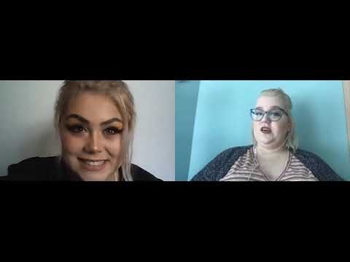
Video not working? Click here:
https://youtu.be/Z3JVhyF3kI0

Once you have completed the activities in the above video, submit them to the website in this word document, below the feedback form.

Feedback Form

This form is an opportunity for you to tell us what you liked and learnt, as well as any feedback on how we could improve the activities.

Strongly Disagree/Disagree/Agree/Strongly Agree
I learnt new ways to generate ideas for environments and to be able to talk about them.
I learnt a way to create an image of an environment through monologue
These techniques will be useful for developing pieces of writing in future
I enjoyed the activities
The tasks were challenging
The tasks were easy to understand
The website is easy to use
The activities put me at ease regarding current world crises
The video was well put together and it was clear what I had to do
I believe drama, theatre and performance can create change in the world
Please use this text box to elaborate further on your answers, or to give any other more specific feedback (Which activity was your favorite? Was something unclear?).

Place your completed activity below:

