WEEK 2

Watch the video below:
(there is also the script written out below so you can see how it was written!)

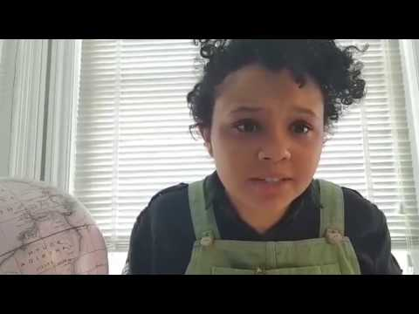
(Video not working? Click here: https://www.youtube.com/watch?v=GR8THCwhshM)

Video Script
(A space soundscape is playing, the screen is dark. It begins with a take-off, then music begins to play, tense initially but then spacey and wonderous. Eva comes onto screen, she is sat in the spaceship)

Eva: (She is sat in the spacecraft, nervously glancing at the participant/camera. She starts smiling at them, trying to catch their attention. She is very nervous.) Hey, I like your shirt. (pause. She acts if the participant has brushed her off.) At least the ship isn’t transparent eh? I don’t know why the sky plane companies thought that was a good idea. I don’t need to see how the engine works or how high off the ground we are thank you. Well, how far from Earth we are. Sorry, that probably doesn’t help. I’m Eva, by the way. Nice to greet you. (beat) You seem to be coping with this much better than me. I never thought anything like this would happen. You wake up one morning and you assume that you can get up and go to work and enjoy a nice feast in the evening, then all of a sudden you’re on a transport vessel to a new planet! Makes me think of all the things I took for granted. (pause) They managed to get 134G for the journey though, pretty decent. (There’s a bang noise) What was that? Oh my deity what’s going on? Can somebody please explain to me what’s going on!?

Narrator: (a voice over with the words on the screen) Write down 5 things that you would say to Eva to reassure her.

Eva: Thank you. Sorry about that. I always assume the worst. Let’s take a look at those things you wrote. Do they contain any assumptions? For example, is there an assumption that the government know what they’re doing? The assumption that we are both physically here? That we are ourselves? Let’s add some other assumptions, like I assume the spaceship is big enough, I assume I can move around the ship, I assume that I can see what’s going on around me.

Narrator: You have 1 ½ minutes to make a list of 8 assumptions.

Eva: I assumed that I would always live on earth. But look at me now through space. Wait, what happens when one of those assumptions changes and is no longer true?

Narrator: Well, that’s where the adventure begins and all the best stories start. You have 1 minute to write down a situation in which each assumption is broken.

Eva: For example, I assume that I can see around me but what if all the lights go out?

Eva: Now these new situations have obstacles to overcome. For example, if all the lights go out, there’s an obstacle that the pilot might not be able to see the controls of the ship, and it might cause panic for the passengers. That means we need to think of tactics to overcome the obstacle, like, I don’t know, using a screen torch? I always get flustered, I need help thinking of tactics.

Narrator: Look at the situations you’ve written and notice if any of them create new obstacles. Pick the most interesting obstacle and write down 5 tactics you could use to overcome the obstacle.

Eva: I can never think of the solution first time, it always takes so many tries. But in the end we always get there. OMD look! Look! We’ve arrived!

Activity:

Comic Strip Activity

Below are 5 boxes (with boxes underneath/beside them to write captions for any pictures).

The first square is the beginning of the story, the exposition, where everything is ok. The assumptions are correct.

The 2nd square is when something happens, an assumption is broken (for example, you have to leave the Earth).

The 3rd square is an obstacle, maybe another assumption is broken and there is something for the characters to overcome (for example, you’re on the ship and the lights go out).

The 4th square are the tactics the characters use to try to overcome the obstacle, usually a few failed tactics and then a successful one (for example, they fail to fix the lights but manage to generate enough light using all the screens that people bought with them to allow the pilot to fly the ship to safety)

The last square is the ending. Did the tactics work? Is it a happy ending? Is there a twist ending? Was what the characters wanted to achieve a good thing? Are there consequences?

You can use the plot that you just generated or something completely different, maybe an idea for your final script. You can draw, create something digitally or just write! Be as creative as you can!
Exposition: When? Where? Who? Inciting Incident: What if everything changed?

The Obstacle: What lies ahead? The Tactics: Is there a way out?

The Ending: Victory or Defeat?

Feedback Form
Week 2

This form is an opportunity for you to tell us what you liked and learnt, as well as any feedback on how we could improve the activities.

Strongly Disagree/Disagree/Agree/Strongly Agree
I learnt new ways to generate ideas for plot
I learnt a way to structure a play
These techniques will be useful for developing pieces of writing in future
I enjoyed the activities
The tasks were challenging
The tasks were easy to understand
The website is easy to use
The activities put me at ease regarding current world crises
These activities made me think differently about the current world crises
I believe drama, theatre and performance can create change in the world
Please use this text box to elaborate further on your answers, or to give any other more specific feedback (Which activity was your favourite? Was something unclear?).

